# CHAPTER 1

# INTRODUCTION

## Need of the system

* + - As of the most recent WHO (World Health Organization) available, it is estimated that about **30%** of the world's adult population has high blood pressure (BP). This figure translates to roughly **1.4 billion** people globally. approximately **80%** of adolescents and about **27%** of adults worldwide do not meet the recommended levels of physical activity.
    - Our app provide a solution for Health related issues like BP Management, Weight Management, Mental Health , etc. Problems. It gives a perfect suggestion for manage your health according the vitals. In modern world we can also live better using this type of technology.

## Detailed problem definition

* + - Design of a mobile application to fulfill requirements such as mental and physical health tracking, wellness tips, and personalized health plans.
    - Well-designed database to store user health information.
    - User-friendly interface for easy interaction with the app's features.
    - Personalized user profiles allowing users to update their information and track progress.
    - Ability for users to log and monitor mental and physical health activities.
    - Provision of daily wellness tips and activity suggestions tailored to users' needs.
    - Functionality for scheduling appointments and consulting with health professionals.

## Viability of the system

* + - The viability of Balance 365 focusing on physical and mental health hinges on strong market demand due to rising health awareness, a unique value proposition that integrates both physical and mental wellness, and the ability to deliver a personalized and user-friendly experience. Technical feasibility, including seamless data integration and expert-driven content, is crucial for sustained user engagement and differentiation from competitors.

## Presently available system

* + - Samsung health
    - HealthPlix
    - Health ( for Iphone )
    - Its is not to more efficient to maintain health.
    - In this system is not very User-Friendly.

## Future prospects

* + - We can add the monthly graph functionality with weekly graph.
    - Use for mobile sensors for the detection of various vitals like blood pressure, heart rate, etc.
    - We add Also the various subscription plans for the client to access the exclusive features of the application.
    - In future the AI integration with chatbot is possible.
    - News and facts related to health can also be made.

# CHAPTER-2

# ANALYSIS

* 1. **Requirement Analysis**

### User Authentication and Authorization

* + - User registration via email or social media (Google, Facebook).
    - Secure user login.
    - Password reset functionality.
    - User profile management.

### Health Data Input and Management:

* + - Ability for users to input various health metrics (age, weight, blood pressure, etc.).
    - Flexibility to add other health metrics based on user needs (heart rate, glucose level, sleep data, etc.).
    - Option to track health data over time (charts, graphs, or trends).

### Data Visualization and Reporting:

* + - Clear and intuitive display of health data (charts, graphs).
    - Ability to generate reports for personal use or sharing with healthcare professionals.
    - Personalized insights based on health data trends.

### Mental Health Quiz:

* + - A series of questions designed to assess the user's mental well-being.
    - Questions should cover various aspects of mental health (stress, anxiety, depression, etc.).
    - Scoring mechanism to provide an overall mental health assessment.
    - Option to retake the quiz periodically to track progress.

### Mental health Resources:

* + - Provide relevant information and resources based on quiz results.

### Video Suggestion Engine:

* + - Analyze user's health data and preferences.
    - Recommend relevant health-related videos based on individual needs.
    - Categories could include exercise routines, healthy recipes, stress management techniques, etc.
    - Option for users to filter or search for specific video types.

### Video Content Management:

* + - Curation or sourcing of high-quality health-related video content.
    - Categorization and tagging of videos for efficient retrieval.
    - Regular updates to the video library.

### User Interaction with Videos:

* + - Ability to play, pause, and control video playback within the app.
    - Option to save or favorite videos for later viewing.
    - Integration with video platforms (e.g., YouTube) for content access.

## Project Model

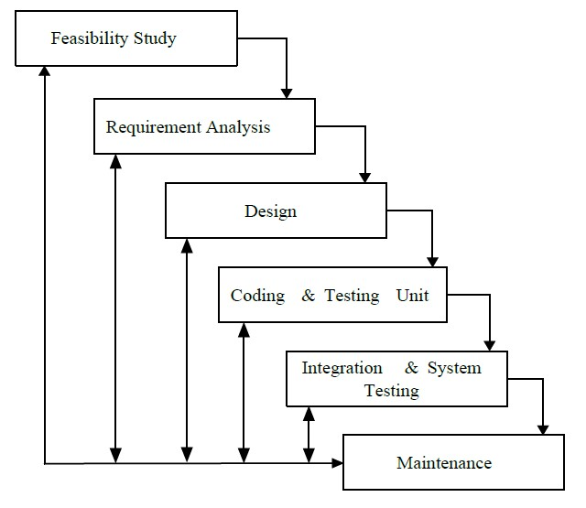

**[Figure 1: Iterative Waterfall Model]**

* + - This application is developed using Iterative model. Almost every other model is derived from the waterfall model.
    - The phase of detecting errors is close to its points of introduction is known as face containment of errors.
    - Incremental model is also referred as the successive version of waterfall model using incremental approach and evolutionary model. In this model, the system has broken down into several modules which can be incrementally implemented and delivered.
    - First develop the core model and when customer evaluate the system then the initial product skeleton is redefined into increasing levels capacity by adding new functionalities in successive versions.

## Advantages

* + - Each successive version performing more useful work than previous versions.
    - The core modules get tested thoroughly, thereby reducing change of error in final product.
    - The model is more flexible and less costly to change the scope and requirement.
    - User gets a change to experiment with partially developed software.
    - This model helps finishing exact user requirements.
    - Feedback providing at each increment is useful for determining the better final product.

## Schedule Representation

Generalized project scheduling tools and technique can be applied with little modification to software projects. Project evolution and review technique and critical paths method are two project scheduling method that can be applied to software development. Both techniques are driven by information already developed in earlier project planning activities:

* + - A decomposition of the product function.
    - The selection of appropriate process model and task set.
    - Estimate of effort.
    - Decomposition of data.

**[Table 1 : Schedule Representation]**

|  |  |  |
| --- | --- | --- |
| **ACTIVITY** | **START DATE** | **FINISH DATE** |
| Requirement Analysis |  |  |
| System Analysis |  |  |
| System Design |  |  |
| System Coding |  |  |
| Testing and Integration |  |  |

## Feasibility Study:

* + 1. **Technical Feasibility:**
* The proposed system for the mental and healthcare application will be developed as a web-based and mobile-friendly application using Flutter and Dart. These technologies are well-suited for creating a seamless and responsive user experience across various devices.
* Firebase will be used as the Database Management System (DBMS), offering real-time data synchronization and efficient data handling, which are critical for the application.
* The necessary technology stack, including Flutter, Dart, and Firebase, is available and capable of meeting the system's requirements.
* Currently available web technology – Flutter, Dart, etc.
* DBMS – Firebase, etc.

## Economical Feasibility:

* + - * Economic feasibility, commonly known as cost/benefit analysis, will be applied to evaluate the effectiveness of the mental and healthcare application. This involves calculating the expected benefits and savings from the system and comparing them with the development and operational costs. If the benefits outweigh the costs, the system will be designed and implemented.

## Operational Feasibility:

* + - * Operational feasibility measures how well the proposed system addresses the issues identified during the scope definition and problem analysis phases, and how effectively it meets the requirements set out in the requirement analysis phase.
      * The application will be user-friendly, with healthcare professionals and patients expected to find the interface intuitive. Training needs will be minimal due to the familiar and accessible design.
      * The system can be implemented within existing networks, with Firebase offering robust security features at both the network and application levels. The use of Flutter and Dart will support an object-oriented approach, ensuring the system's flexibility and smooth operation.
      * Data security will be prioritized, with different access levels established for various users. Firebase's authentication, authorization, and audit features will support secure system management.
      * Efficient data retrieval processes will be implemented, leveraging Firebase's capabilities for real-time data access.